### **8. Social Media / Bite-Sized Summary**

> "Write a short, engaging 3-4 sentence summary about the youth of India suitable for sharing on social media."

Sonar-
India is home to the world's largest youth population, with about 370 million people aged 15-24, making up 27% of its total population. This vibrant young generation drives innovation, especially in technology, education, and entrepreneurship, powering sectors like MSMEs and digital startups. While this demographic offers immense potential for economic growth and social change, challenges like youth unemployment and urban-rural education gaps remain. Social media plays a pivotal role in connecting Indian youth globally, enhancing learning and activism, but also presents risks like cyberbullying[1][3][7][2][4].
•2.5 Flash Lite-
India's youth, a vibrant demographic representing the largest youth population globally, are increasingly seeking purpose-driven careers and are at the forefront of driving social and technological change. While facing challenges like unemployment and mental health concerns, they remain optimistic about their future prospects and are actively engaging with digital platforms. Their aspirations, a blend of material well-being and personal fulfillment, are shaping the nation's trajectory towards a developed economy.
References:
- "India's youth seek purpose-driven careers in changing work landscape": This article highlights the evolving career aspirations of Indian youth and their desire to influence economic systems.
- "Youth in India - Wikipedia": This provides a comprehensive overview of youth-related issues in India, including education, employment, and social challenges.
- "India’s Youth Dividend: High Hopes for Today and Tomorrow": This source discusses the optimism of young Indians regarding job prospects despite unemployment rates and their active engagement with global issues.
- "Youth of India Foundation": This provides information about an organization dedicated to empowering Indian youth for social change and enhancing employability.
- "NSN India Interface: WYSD 2025 | Shaping Youth Aspirations": This article emphasizes the growing relevance of AI and digital skills for youth empowerment.
•GPT-5 Nano-
India’s youth are the world’s largest generation, with about 65% under 35 and roughly 370 million aged 15–29. They are tech-savvy, digitally connected, and eager to shape a sustainable, inclusive future through skills, entrepreneurship, and innovation. Government programs like the National Youth Policy (NYP) and PMKaushal Vikas Yojana (PMKVY) fuel their growth, while young changemakers drive progress in education, work, and civic life. In short, India’s young people are a powerful asset and the country’s brightest hope for global leadership.
References:
- PIB: National Youth Day 2025 - PRID=2092084 — Official government overview of youth development and vision. https://www.pib.gov.in/Pressreleaseshare.aspx?PRID=2092084
- UNICEF India: Youth topic — Provides demographics (371M aged 15–29; ~40% of population) and context on youth empowerment. https://www.unicef.org/india/topics/youth
- MOSPI: Youth in India 2022 (Overview) — Government statistical profile of youth demographics and indicators. https://mospi.gov.in/sites/default/files/publication_reports/Youth_in_India_2022/Overview.pdf
- Orfonline: National Youth Policy — Expert analysis of NYP and India’s youth development trajectory. https://www.orfonline.org/expert-speak/national-youth-policy
- Economic Times Education: Empowering Change — How India’s youth are transforming communities on International Youth Day 2025. https://education.economictimes.indiatimes.com/news/higher-education/empowering-change-how-indias-youth-are-transforming-local-and-global-communities-on-international-youth-day-2025/123253305
•Grok 4 Fast-
India's youth, making up nearly two-thirds of the population under 35, are a powerhouse of energy and innovation, driving the nation toward a brighter future amid global changes. On International Youth Day 2025, they're embracing AI, digital skills, and purpose-driven careers to tackle challenges like unemployment, mental health pressures, and skill gaps head-on. From sustainable community transformations to economic aspirations, these young trailblazers are not just surviving—they're shaping India's demographic dividend into a force for global impact. Let's celebrate and empower them! #IndianYouth #YouthDay2025
- International Youth Day 2025: Skilling India's Youth for a Changing World (https://www.orfonline.org/expert-speak/international-youth-day-2025-skilling-india-s-youth-for-a-changing-world): Highlights India's youth's role in skilling for global challenges, relevant for the innovation and empowerment angle.
- India's youth seek purpose-driven careers in changing work landscape (https://www.indiatoday.in/education-today/featurephilia/story/indias-youth-seek-purpose-driven-careers-in-changing-work-landscape-2721484-2025-05-08): Discusses evolving career aspirations, key to portraying youth's proactive mindset.
- The Major Problems Faced by Indian Youth in 2025 - LinkedIn (https://www.linkedin.com/pulse/major-problems-faced-indian-youth-2025-facts-figures-way-sagar-hedau-7qpbf): Provides current challenges like unemployment and mental health, essential for a balanced view.
- gst 2.0 and youthful india's economic future (https://universalinstitutions.com/gst-2-0-boosting-indias-youth-economy-2025/): Emphasizes demographic dividend and aspirations, supporting the economic impact narrative.
Deep Research
India's Youth: A Demographic Powerhouse Driving Global Change
Unveiling the aspirations, challenges, and transformative potential of India's vibrant young generation.

43+ Sources
- 1.Highlights of India's Youth Landscape
- 2.Understanding the Scale of India's Youth Demographic
- 3.The Aspirations and Driving Force of Indian Youth
- 4.Key Challenges Faced by Young Indians
- 5.Government Initiatives and Support Systems
- 6.Visualizing Youth Aspirations and Challenges
- 7.The Interconnected Web of Youth Issues
- 8.A Deep Dive into the "Rising Bharat Summit 2025"
- 9.Comparative Analysis of Youth Characteristics
- 10.FAQ about Indian Youth
- 11.Conclusion
- 12.Recommended Further Exploration
- 13.Referenced Search Results

Highlights of India's Youth Landscape
- Largest Youth Population: India is home to the world's largest youth demographic, representing a significant portion of its total population and offering immense human potential.
- Drivers of Innovation & Change: This tech-savvy generation is actively shaping the future through entrepreneurship, digital skills, and a strong desire for purpose-driven careers and social impact.
- Navigating Challenges: Despite facing hurdles like unemployment, mental health concerns, and skill gaps, Indian youth maintain optimism and are proactive in seeking solutions and contributing to national development.
India stands at a pivotal moment in its history, powered by the largest youth population in the world. With approximately 370 million individuals aged 15-24, and nearly two-thirds of its population under 35, this demographic dividend is not just a statistic but a vibrant force shaping the nation's trajectory. This young generation is characterized by its digital fluency, entrepreneurial spirit, and a profound aspiration for a sustainable and inclusive future, making them key drivers of innovation and social change.

Understanding the Scale of India's Youth Demographic
The sheer size of India's youth population is unparalleled globally. Estimates suggest that roughly 370 million people fall within the 15-29 age bracket, representing around 40% of the total population. This significant demographic bulge presents both extraordinary opportunities and considerable challenges for the nation's development. This generation is not merely a passive recipient of future policies but an active participant in shaping them, with their aspirations and engagements dictating many aspects of India's economic and social landscape.
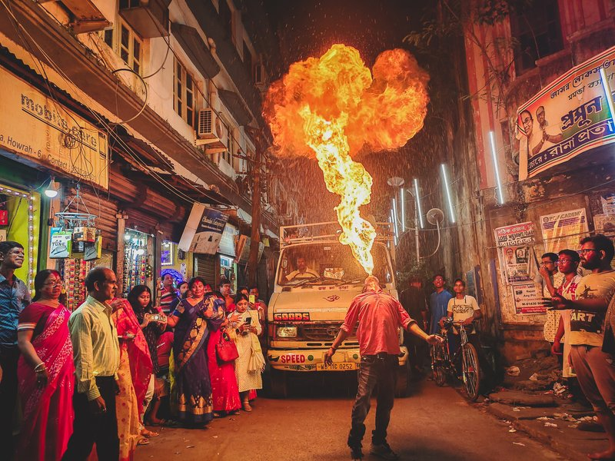
Young individuals contributing to community initiatives.
Demographic Distribution and Influence
The concentration of young people is seen across various sectors, from urban centers to rural communities, each bringing unique perspectives and needs. This widespread distribution ensures that their influence is not localized but permeates all aspects of Indian society. From political discourse to economic trends, the youthful demographic's choices and behaviors are increasingly central to India's identity and future positioning on the global stage. Their collective voice, amplified through digital platforms, is a potent force for change.

The Aspirations and Driving Force of Indian Youth
India's youth are characterized by a dynamic blend of high hopes and pragmatic ambitions. They are increasingly gravitating towards purpose-driven careers, seeking not just financial stability but also personal fulfillment and the opportunity to make a tangible impact. This shift in aspirations is transforming the employment landscape and fostering a new wave of entrepreneurship.
Innovation and Entrepreneurship
With a strong inclination towards technology, many young Indians are at the forefront of digital innovation. They are leveraging their skills to develop startups, particularly in the Micro, Small, and Medium Enterprises (MSME) sector, and are keen on embracing emerging technologies like Artificial Intelligence. This entrepreneurial zeal is crucial for job creation and economic diversification.
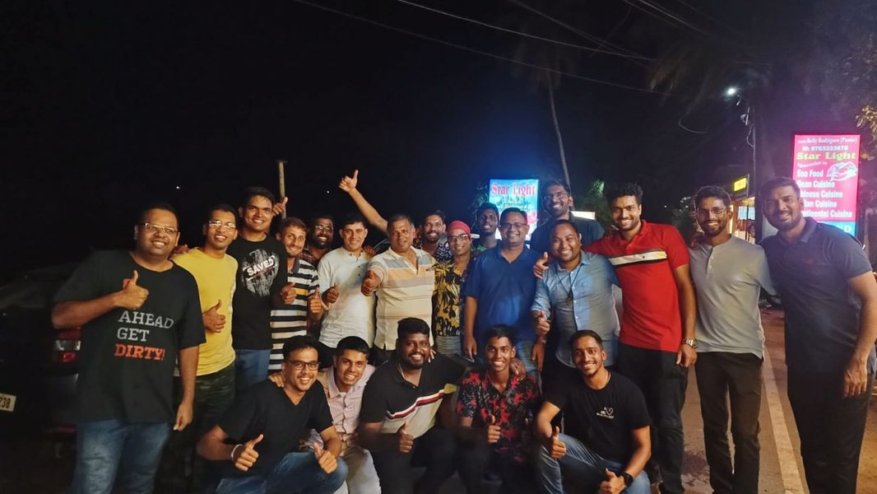
Youth actively participating in a workshop, symbolizing their engagement and thirst for knowledge.
Digital Connectivity and Social Impact
Social media and digital platforms serve as powerful tools for Indian youth, enabling them to connect globally, access educational resources, and engage in social activism. This digital engagement fosters a sense of global citizenship and empowers them to advocate for causes ranging from environmental sustainability to social justice. They are not merely consumers of digital content but active creators and catalysts for online movements.

Key Challenges Faced by Young Indians
Despite their immense potential, Indian youth encounter a range of significant challenges that necessitate focused interventions. Addressing these issues is paramount to harnessing their full potential and ensuring equitable development.
Unemployment and Skill Gaps
One of the most pressing concerns is youth unemployment, which, despite economic growth, remains a persistent issue. This is often exacerbated by skill gaps, where the education system may not fully align with the demands of the modern job market. Many young people struggle to find opportunities that match their qualifications, leading to underemployment or extended periods of job searching.
Mental Health Concerns
The pressures of academic performance, career aspirations, and societal expectations contribute to growing mental health concerns among Indian youth. Issues such as stress, anxiety, and depression are increasingly prevalent, highlighting the need for robust mental health support systems and awareness campaigns. The competitive environment, coupled with rapid social changes, can take a toll on their well-being.
Bridging the Urban-Rural Divide
Disparities in educational access and opportunities persist between urban and rural areas. While urban youth often have access to advanced educational facilities and digital infrastructure, their rural counterparts may face limitations in resources and exposure. Bridging this gap is crucial for fostering inclusive growth and ensuring that opportunities are available to all, regardless of geographical location.

Government Initiatives and Support Systems
Recognizing the critical role of youth in national development, the Indian government has implemented several policies and programs aimed at empowering them. These initiatives focus on enhancing skills, promoting entrepreneurship, and ensuring overall well-being.
National Youth Policy (NYP) and Skill Development
The National Youth Policy (NYP) provides a comprehensive framework for youth development, addressing various aspects of their lives, including education, employment, and health. Programs like the PM Kaushal Vikas Yojana (PMKVY) are specifically designed to impart vocational training and industry-relevant skills, thereby improving employability and reducing skill gaps. These programs are vital in preparing the youth for a rapidly evolving global economy.
Fostering an Ecosystem for Young Changemakers
Beyond formal education, there is a growing emphasis on creating an ecosystem that supports young changemakers. This includes encouraging participation in civic life, supporting community-led initiatives, and providing platforms for innovation. Such environments empower youth to actively contribute to solving societal problems and shaping a better future.

Visualizing Youth Aspirations and Challenges
To better understand the multifaceted nature of India's youth, let's look at some key aspects through visual representations. The radar chart below illustrates their primary aspirations, while the bar chart highlights the significant challenges they encounter.
The radar chart above illustrates the strong aspirations of Indian youth across various dimensions, with high scores in career advancement, personal growth, and digital innovation.
This bar chart highlights the most significant challenges confronting Indian youth, with mental health and unemployment being prominent concerns.

The Interconnected Web of Youth Issues
Understanding the challenges and aspirations of Indian youth requires recognizing the intricate connections between various factors. A mindmap can visually represent this complex interplay, showing how different aspects influence each other.
Indian Youth LandscapeDemographicsLargest Youth Population~65% under 35AspirationsPurpose-Driven CareersInnovationSustainabilityGlobal ImpactFinancial StabilityChallengesUnemploymentSkill GapsMental Health ConcernsEducational DisparitiesCyberbullying RiskEnablersDigital ConnectivityGovernment PoliciesNational Youth Policy (NYP)PM Kaushal Vikas Yojana(PMKVY)Entrepreneurship SupportImpact on NationEconomic GrowthSocial ChangeGlobal Leadership
The mindmap above illustrates the complex network of demographics, aspirations, challenges, and enablers that define the Indian youth landscape, highlighting their interconnectedness.

A Deep Dive into the "Rising Bharat Summit 2025"
The "Rising Bharat Summit 2025" is a significant event that underscores the growing importance of India's youth in shaping the nation's future. This summit serves as a crucial platform for dialogue, collaboration, and action, bringing together leaders, innovators, and young minds to discuss pressing issues and future strategies.
This video captures a live session from the News18 Rising Bharat Summit 2025, emphasizing the active role of India's youth in leading national progress. It showcases discussions and insights from young leaders, entrepreneurs, and students, highlighting their perspectives on India's future and their commitment to driving change. The summit acts as a microcosm of the larger national effort to harness the demographic dividend, focusing on how youthful aspirations translate into concrete actions for development and global impact.
The summit's focus on "Youthful Aspirations" reflects a national recognition of the dynamic potential residing within India's young generation. It aims to bridge the gap between policy-makers and the youth, ensuring that their voices are heard and their concerns are addressed. Themes such as skilling for a changing world, embracing AI and digital technologies, and fostering purpose-driven careers are central to the discussions, mirroring the key aspirations and challenges identified among young Indians.

Comparative Analysis of Youth Characteristics
To further contextualize the profile of Indian youth, a comparative table highlights key characteristics and their implications.
Characteristic | Description | Implication for India
Digital Natives | Highly proficient in digital technologies and social media. | Facilitates rapid dissemination of information, innovation, and global connectivity.
Entrepreneurial Drive | Strong inclination towards starting their own ventures and creating new solutions. | Drives job creation, economic diversification, and addresses market gaps.
Purpose-Driven | Seek careers and activities that offer personal fulfillment and societal impact. | Fosters a socially conscious workforce and promotes sustainable development goals.
Global Outlook | Connected to international trends and ideas, eager to contribute on a global scale. | Enhances India's soft power and contributes to international collaborations.
Resilience | Despite challenges, maintain optimism and a proactive approach to problem-solving. | Crucial for navigating socio-economic hurdles and maintaining progress.
This table outlines several defining characteristics of India's youth, explaining their nature and the broader implications for the nation's progress and standing in the world.

FAQ about Indian Youth
What is the current youth population of India?
What are the primary aspirations of Indian youth?
What challenges do young people in India face?
How is the Indian government supporting its youth?
How are Indian youth impacting the nation's future?

Conclusion
The youth of India represent an extraordinary demographic dividend, a generation poised to redefine the nation's future. Their boundless energy, digital prowess, and strong desire for purpose-driven lives are powerful catalysts for innovation, economic growth, and social progress. While navigating significant challenges like unemployment, skill mismatches, and mental health issues, their optimism and resilience shine through. Government initiatives and a burgeoning ecosystem for changemakers are working to harness this potential, paving the way for India to assume a prominent role on the global stage. Empowering this vibrant generation is not merely a policy objective but a strategic imperative for India's sustained development and leadership.

Recommended Further Exploration
- Explore the impact of digital literacy on Indian youth employment trends.
- Investigate government schemes and their effectiveness in youth skill development in India.
- Delve into the current state of mental health support for young people in India and future strategies.
- Analyze the emerging trends and challenges in youth entrepreneurship in India.

Referenced Search Results
unicef.org
Youth topic - UNICEF India
mospi.gov.in
Youth in India 2022 (Overview) - MOSPI
orfonline.org
National Youth Policy - ORFonline
education.economictimes.indiatimes.com
Empowering Change - How India’s youth are transforming communities on International Youth Day 2025 - Economic Times Education
orfonline.org
International Youth Day 2025: Skilling India's Youth for a Changing World - ORFonline
indiatoday.in
India's youth seek purpose-driven careers in changing work landscape - India Today
linkedin.com
The Major Problems Faced by Indian Youth in 2025 - LinkedIn
universalinstitutions.com
gst 2.0 and youthful india's economic future - Universal Institutions
indian-street-youth-photos.blogspot.com
In the Spotlight | Indian Street Youth - Photos and Story - Indian Street Youth Photos
indiatoday.in
More than half of Indian youth aged 9-17 spend over 3 hours daily ...
internationalbanker.com
Unemployed Youth Are Still the Achilles Heel of India's Buoyant ...
news.youngindia.foundation
‘Youth’ in India: A Critical Assessment of Defining and Categorising Youth
imnidhi.com
Cracking the Code: An Insider's Guide to Understanding Consumer ...
indianyouth.org
Understanding the Strengths and Challenges of Native Youth Today
ijciss.com
THE MULTIFACETED CHALLENGES FACED BY YOUTHS OF INDIA
radjapublika.com
THE IMPACT THAT SOCIAL MEDIA HAS HAD ON TODAY'S GENERATION OF INDIAN ...
india.gov.in
Youth| National Portal of India
indianyouth.net
Indian Youth | Voice of India
mospi.gov.in
Youth in India Publication, 2022
ncbi.nlm.nih.gov
Health behaviours & problems among young people in India: Cause ...
pmc.ncbi.nlm.nih.gov
Perception, use of social media, and its impact on the mental health ...
news.gallup.com
India's Youth Dividend: High Hopes for Today and Tomorrow
pmc.ncbi.nlm.nih.gov
Is it time for India to set social media age limits for adolescents?
youthofindia.org.in
Home - Youth of India Foundation
linkedin.com
NSN India Interface: WYSD 2025 | Shaping Youth Aspirations ...
researchgate.net
(PDF) THE IMPACT THAT SOCIAL MEDIA HAS HAD ON TODAY'S GENERATION ...
indiatoday.in
youthspeak
pib.gov.in
India’s Growing Focus on Youth and Sports
indiafacts.in
Internet & Social Media Usage among youth in India: Mcafee Report ...
indianexpress.com
Mental health in India: Impact of social media on young Indians ...
thecsrjournal.in
Problems India’s youth is facing today - The CSR Journal
iuemag.com
The Shifting Dreams of India's Youth: From Survival to Significance
indiatoday.in
Youthspeak: The audacity of youth
indianyouth.net
New trends on the rise among the Youth | Indian Youth
careme.health
The Impact of Stress and Anxiety on Indian Youth: How to Cope
dandc.eu
Youth unemployment remains one of India's great challenges
avaada.com
The power of Indian Youth in Transforming the World's Future
pib.gov.in
National Youth Day 2025 - PIB
indiatoday.in
Youth movements
price360.in
People Research on India’s Consumer Economy & India’s Citizen Environment - ICE360
diplomaticourier.com
India's Youth Dividend: High Hopes for Today and Tomorrow
en.wikipedia.org
Youth in India - Wikipedia
youthindiatoday.com
Homepage - Youth India News
ruralindiaonline.org
Youth in India 2022

